WIL TASK 1

Contents
Team Members 2
Introduction 3
WBS 4
Gannt Chart 4
Risk Management 4
Technical Feasibility 5
ECONOMIC FEASIBILITY OF SHANNON FOOD TRUCK BUSINESS 6

Team Members
Kamv’elihle Dyantyi(ST10434588)
Neziswa Bikitsha(ST10442069)
Amandla Sekeleni (ST10456349)
Katleho Khutsoane (ST10442069)

Introduction
This project aims to develop a digital ordering and management plat form for Shannon’s fast -food truck business, which is currently scaling its operations from two to three active trucks.The business specializes in providing warm ,comforting local food – such as amagwinya and beverages to customers on the go and there famous Kotas’s .typically within a quick q0 to 15 minute turnaround. To support and accelerate this growth , the primary goal for the project is to build either a dedicated mobile application or a responsive website(pending the clientts’s final decision) that enables customers to browse the menu , place orders online , and book services.
Currently , there are minimal u[front cost constraints.Anticipated financial requirements will primarily relove around operation and infrastructure costs , such as web hosting and scalable database strorage. As the application user base grows , the system is desfgined to seamlessly transition to premium service tiers on platforms like Supabase or Firebase, to host the large amounts of users. Ultimately the success of this digital solution will be measured by its ability to deliver enhanced brand exposure, drive measurable business growth , reach a wider audience and cultivate a stronger , more connected community around the brand , especially here in Parklands where Shannon is based.

WBS
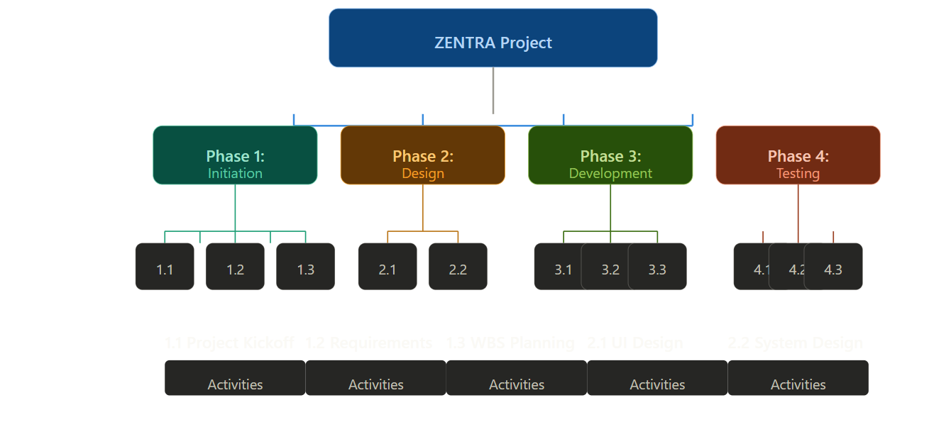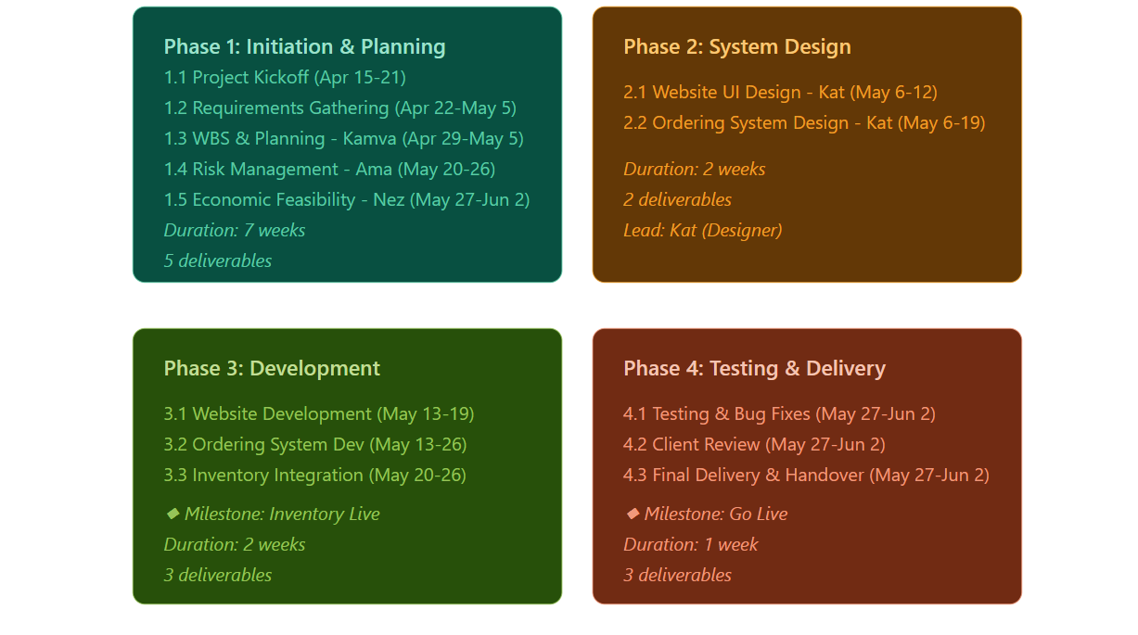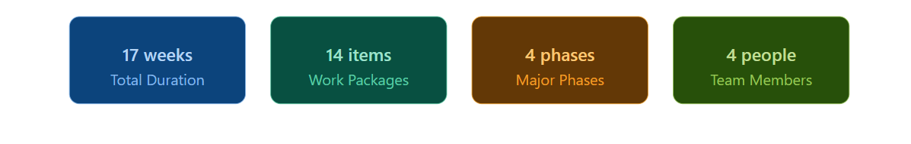

Gannt Chart
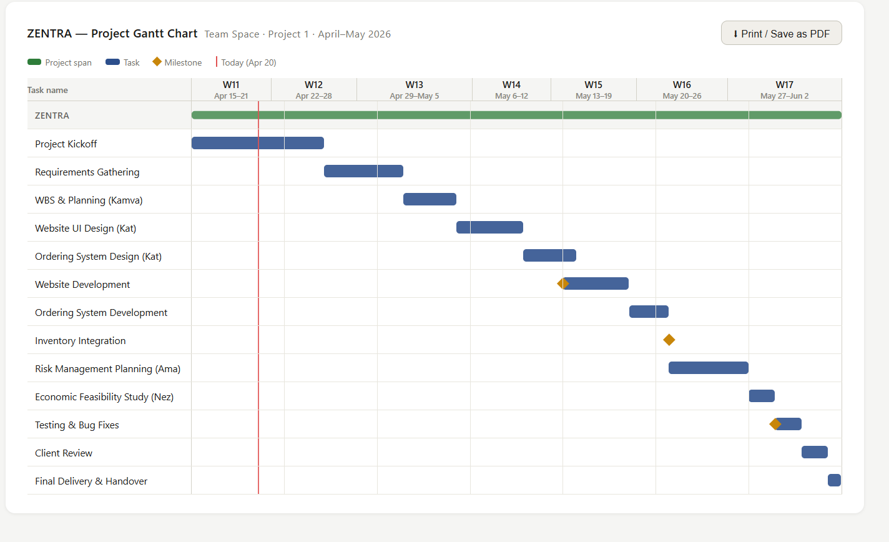

Risk Management

Every project is exposed to risks that could affect its success, timeline, or budget. The table below identifies the key risks for the Shanon Food Truck Online Ordering System, assesses the probability and impact of each risk, and outlines the proactive steps the team will take to manage them. Probability and impact are rated on a five-point scale: Very Low, Low, Medium, High, and Very High.
5.1 Rating Scale
Both Probability and Impact are rated using the same five-point scale. The colours below are used in the risk table to make it easy to see immediately which risks need the most attention:
Colour | Rating | What it means
 | Very Low | Very unlikely to happen and would barely affect the project
 | Low | Not very likely and easy to manage if it does happen
 | Medium | Could happen and would need attention if it does
 | High | Likely to happen and would seriously affect our timeline or quality
 | Very High | Almost certain or would cause major damage to the project

5.2 Risk Register
Risk | Description | Probability | Impact | Proactive Steps
Team Member Leaves | One of our group members could drop the course or become unavailable during the project. | Low | High | We will keep all our work on GitHub so anyone can pick up where someone left off. We also share responsibilities so no one person holds everything.
No Cooperation from Client (Shanon) | Shanon might be too busy to meet with us or give feedback on time, which could slow us down. | Low | High | We will set up meetings with her in advance and send written questions over WhatsApp so she can reply when she has time. We will also confirm everything she says in writing.
Lack of Technical Skills | Some of us may not have experience with certain things like web development or database design. | Medium | Medium | We will figure out who is good at what early on and assign tasks accordingly. If someone is struggling, we will use YouTube tutorials or ask for help from classmates.
Team Member Not Contributing | A group member might not do their share of the work, putting extra pressure on the rest of us. | Medium | High | We will check in every week and track who has done what using our WBS. If someone keeps not pulling their weight, we will raise it with the lecturer.
Falling Behind Schedule | Some tasks might take longer than we expected, causing us to miss submission deadlines. | Medium | High | We will use our Gantt chart to check progress every week. We also added some extra time to tasks we think might be tricky, just in case.
Scope Creep | Shanon might ask us to add extra features that were not part of the original plan, like delivery tracking or loyalty cards. | Medium | Medium | We will make sure our agreed scope is clearly written in the project plan. If she wants to add something new, we will discuss whether it is feasible before agreeing to it.
Losing Our Files | Files could get deleted by accident or team members could end up working on different versions of the same document. | Low | Very High | We will use GitHub for all our code for documents. We will commit changes regularly and avoid working on the same file at the same time without communicating.
Hardware or Internet Problems | A laptop could break or someone might not have internet access, making it hard to work. | Low | Medium | We will use cloud-based tools, so our work is not stuck on one device. The campus computer labs are always available as a backup.
Going Over Budget | We might spend more hours on certain tasks than we planned for, which pushes the project cost up. | Low | Medium | We will track our hours per task and compare them to our estimates every week. If we are going over on one task, we will adjust our plans before it gets out of hand.
Miscommunication in the Team | We might misunderstand what each person is supposed to do, leading to duplicate work or things being missed. | Medium | Medium | We have a group chat for daily updates, and we write down decisions after every meeting. Task assignments are always confirmed in writing so there is no confusion later.

5.3 How We Will Manage Risks
We will go through this risk table at the start of every team meeting to see if anything has changed. If a new risk comes up that we did not think of before, we will add it to the table and decide who is responsible for keeping an eye on it. If a risk happens, we will deal with it straight away using the steps we have already planned and make a note of what happened in our meeting minutes.

Technical Feasibility
To successfully develop and implement this system , specify hardware and software resources are required. The development team has assessed the necessary tools and current availability to ensure project viability.
- Hardware Resources:Required and available resources ; Personal Computers and laptops , accompanied by standard peripherals(monitors , keyboards and mouse).
- Statuse :All necessary resources are currently available to the development team.
- Software Resources: Depending on the final decision regarding the platform architecture(Native App , Web App or Hybrid/PWA), the team will utilize the following software stack :
- Operating System :Windows OD for development environment.
- Integrated Development Environment(IDE) Android Studio for mobile application development or could be Visual studio for a more web-based development
- Programming Languages: Kotlin(Android app logic) , SQL(for database querying and data management).
- Design Tools: UI/UX design software most likely Figma or Framer to prototype and structure the visual interface.
- Statues : All required software licenses and open-source tools are available to the team.
Item | Specification required | Quantity | Available?(Yes/No) | If No, solution
Laptop/Computer | Windows 10/11 or macOS, 8GB+ RAM, 256GB+ storage | 4 | Yes | Every team member has a laptop
External Monitor | 1080p resolution, HDMI/USB-C connection | 1 | No | Use Lab computer on campus
USB Flash drive(backup) | 32GB+ capacity | 2 | No | Purchase from local store
Smartphone (for mobile testing) | Android or iOS with internet browser | 2 | Yes | Team members all own smartphones
Internet connection(per team member) | Stable connection, 10Mbps+ | 4 | Yes | All Team members have Wi-Fi
Power supply/chargers | Standard laptop charger | 4 | Yes | Team members all have chargers

Current Technical Issues & Constraints
While the necessary resources are secured , the team is currently managing a specific constraint regarding the development environment.
- Emulator Performance: Running Android Virtual Devices (emulators) within Android Studio is proving to be highly resource-intensive, causing performance bottlenecks on the available hardware.
- Mitigation Strategy: The team is currently exploring workarounds, such as debugging directly via physical Android devices rather than relying on virtual machines.
A final, concrete structural decision regarding the exact system architecture remains pending while these hardware performance issues are resolved and the client finalizes their preference between a web-based or application-based solution.

ECONOMIC FEASIBILITY OF SHANNON FOOD TRUCK BUSINESS
Economic feasibility basically answers the question “Does the financial gain of building this system outweigh the cost of building it?”. Since Shanon is a small business owner, the system must either make her more money or save her money to be worth it otherwise it’s not worth the money invested into building the system.

Activity/Task | Team member responsible | Time allocated per task per team member | Tariff per team member in rands per hour | Cost per task (time*tariff)
Project Initiation | All members | 18 | R300 | R5400
WBS & Planning | Kamv’elihle | 8 | R250 | R2000
Website UI Design | Katleho | 16 | R180 | R2880
Ordering System Design | Katleho | 20 | R200 | R4000
Website Development | All Team members | 24 | R220 | R5280
Ordering system Development | All Team members | 32 | R220 | R7040
Inventory integration | All Team members | 12 | R250 | R3000
Risk Management Planning | Amandla | 6 | R250 | R1500
Economic Feasibility Study | Neziswa | 10 | R235 | R2350
Testing & Bug fixes | All Team members | 6 | R217(avg) | R1302
Client Review | All Team Members | 4 | R217 | R868
Final Delivery & Handover | All Team members | 4 | R217 | R868
Total Hours and Total Budget |  | 160 |  | R36 480

Economic Feasibility Conclusion (Effort-Based):
The total estimated effort for the Shanon's Food Truck project is 160 person-hours, resulting in a total labour budget of R36 480 (excluding hardware, software, or hosting costs). This calculation is based on a four-person team with hourly rates ranging from R180 to R250 per hour, using the conversion of 1 session = 40 hours. Given the expected savings from reduced food waste (estimated at R4,000+ annually) and improved labour efficiency (estimated at R10,400+ annually), the project remains economically feasible with a projected payback period of approximately 4–5 months.

